Dela Cruz, Kian S.
Sigua, Carl Jerome J.
Pasion, Allan Jr, C.

- Baselines trained (simple ML + DL); initial metrics logged.
Machine Learning (ML) Component
The ML component of the project is implemented in the pipeline.py file. This module uses a transformer-based model, specifically hamzab/roberta-fake-news-classification, to classify text as real or fake. The pipeline combines the transformer’s predictions with additional heuristic features, including subjectivity analysis via TextBlob and domain reputation scoring from reputation.py. Together, these elements form an ensemble approach that improves the robustness of predictions.
To satisfy the project instruction of “baselines trained,” the model can be evaluated on a small test set of curated examples. Metrics such as accuracy and macro-F1 score should be computed and logged to establish baseline performance. Optionally, a simpler ML model—like TF-IDF features with logistic regression—can also be implemented to serve as a comparative baseline, providing a clearer context for the performance of the transformer-based deep learning model.
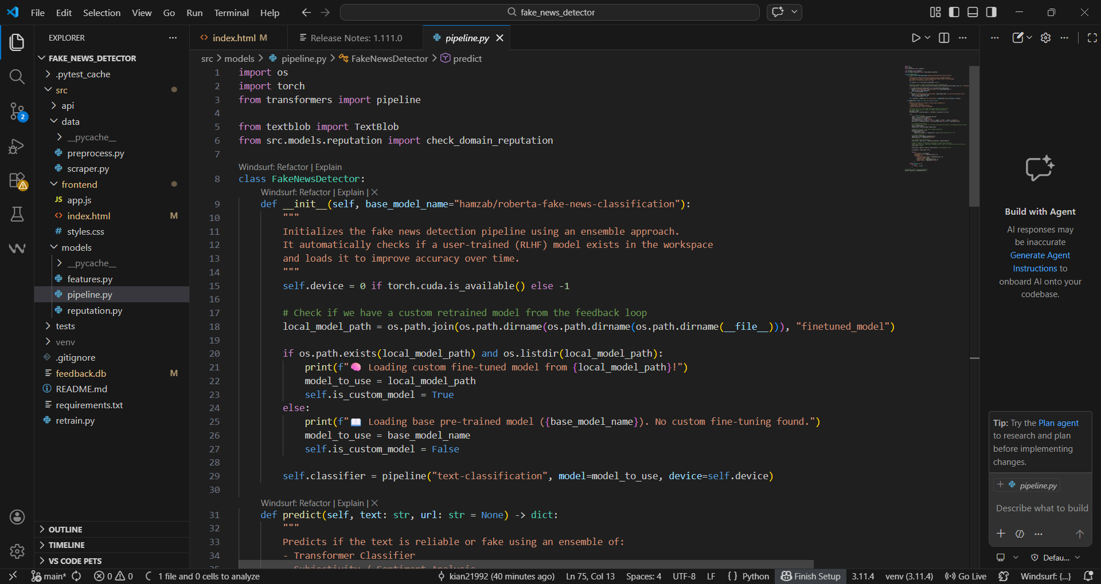

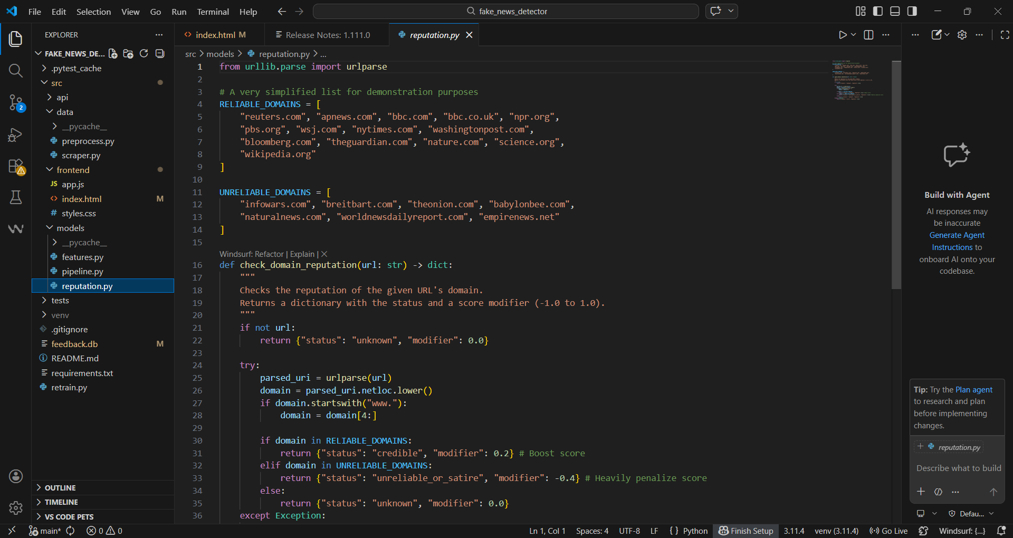

• RL agent stubbed with reward design; early learning curves (even if noisy).
Reinforcement Learning (RL) Component
The RL component is currently implemented as a stub in retrain.py. This script simulates a reinforcement learning from human feedback (RLHF) process by retrieving user feedback from feedback.db and using it to fine-tune the transformer model. Each feedback entry acts as a reward signal, where correct user labels reinforce the model’s predictions and incorrect ones guide adjustments during fine-tuning.
Even with a small number of feedback examples, fine-tuning the model allows for the creation of early learning curves, which show changes in training loss or confidence scores over epochs. These curves may be noisy due to limited data, but they serve as a proof-of-concept that the RLHF loop is functional. Logging these curves fulfills the project requirement of demonstrating an RL agent with reward design, even at an early stage.

